**LAB Assignment-3**

**Mashup Application:**

As part of the mash up application I created a zip code tracker app. When we give a zip code to the app then it displays the nearby places, zip codes and distance from the input zip code. After that I pointed those zip codes on Google map by parsing the latitude and longitude values in the Json data as the input of the map.

Screenshots of the app is given below.

API's: Geonames.org and google maps.

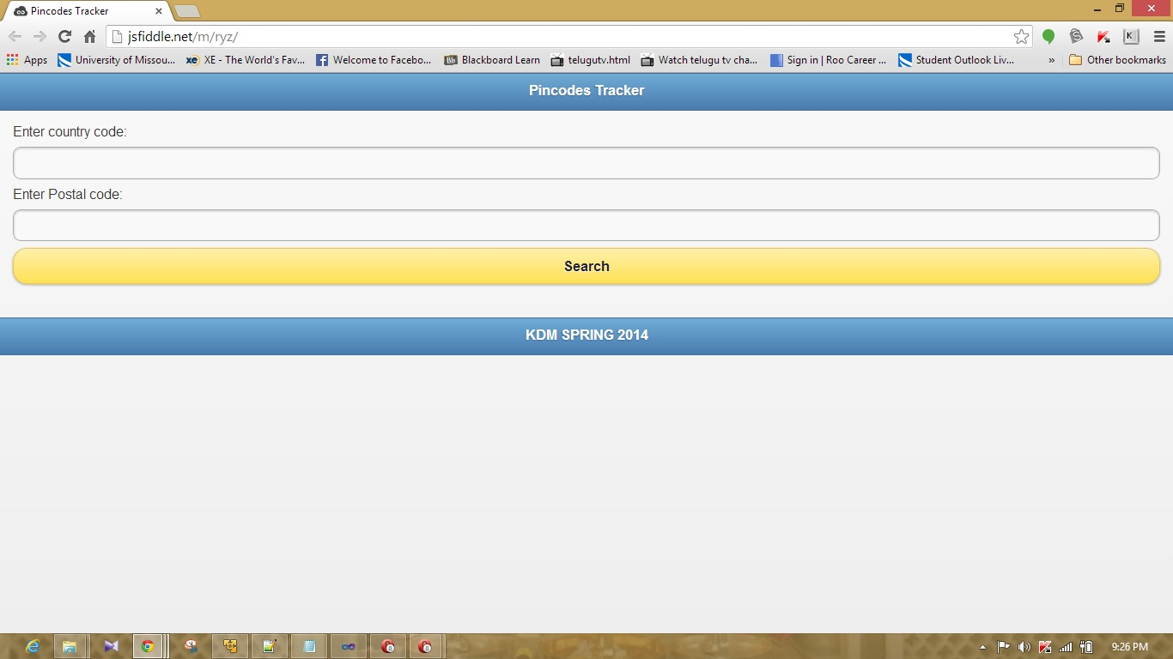

The above screenshot represents the mainpage of the app. Inputs to this app is the country code and postal code.

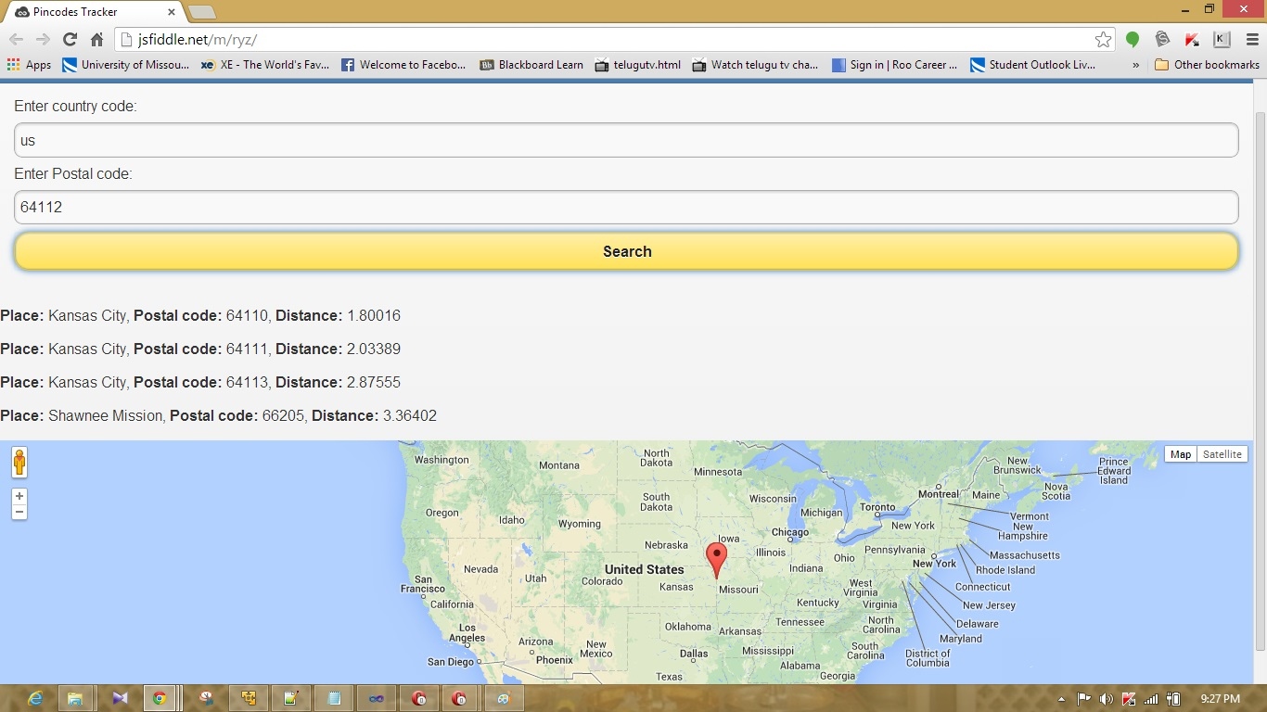

Above screen shot represents the postal codes of the places nearby to the given postal codes and distance of the places from the given postal code. Places are marked on the google maps as shown above.

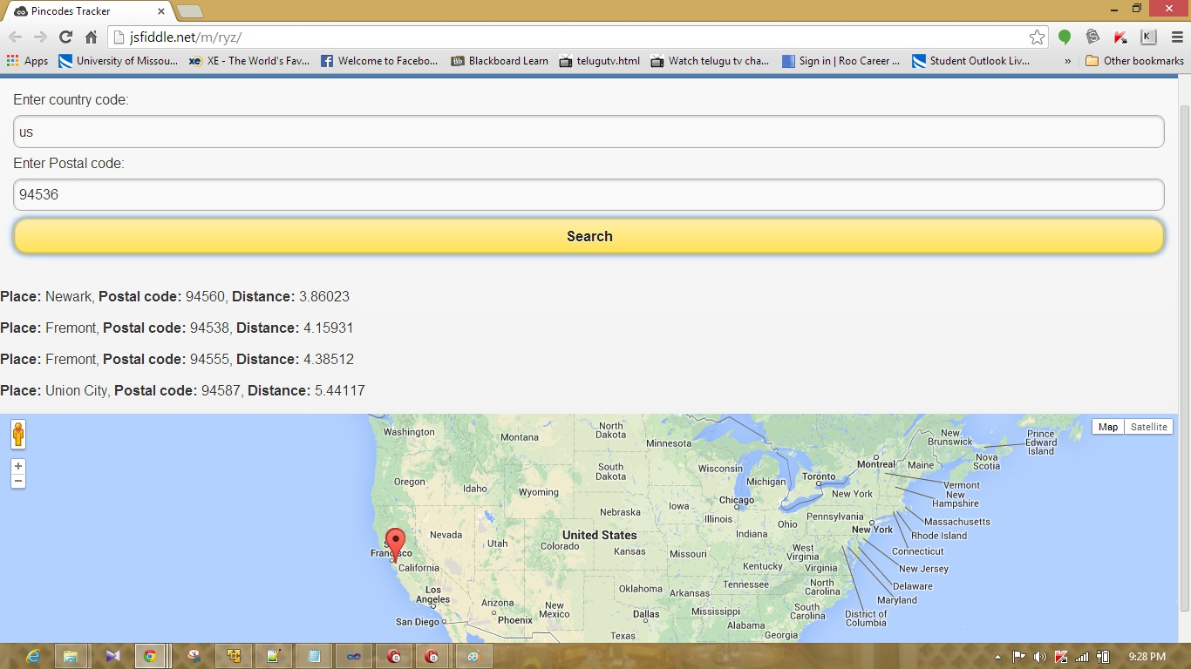

Above Screenshot represents the postal codes of the different place.

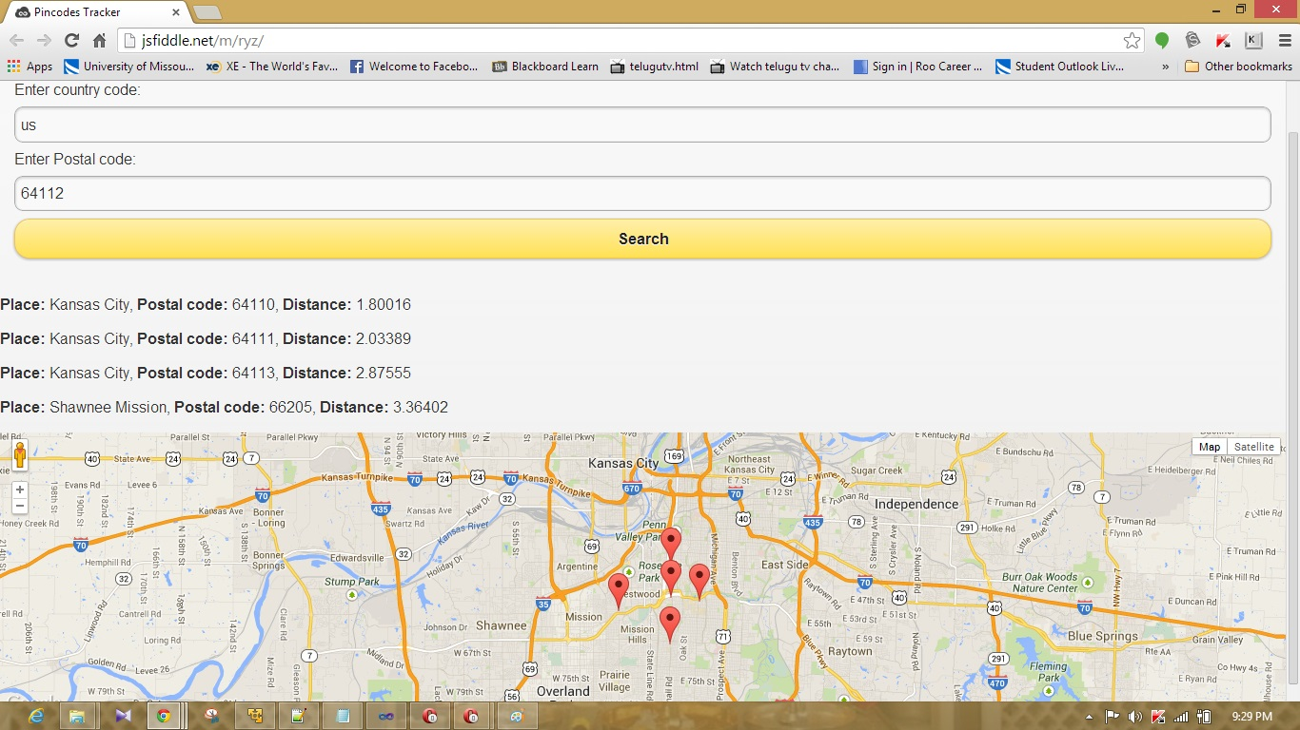

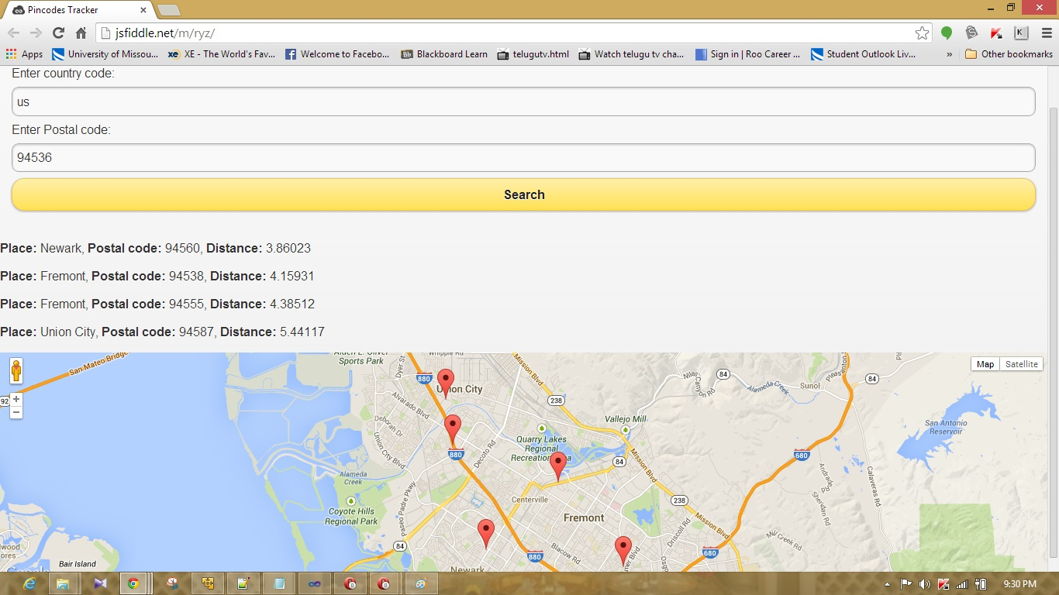

Above screenshot represents the Places marked in the Google maps.

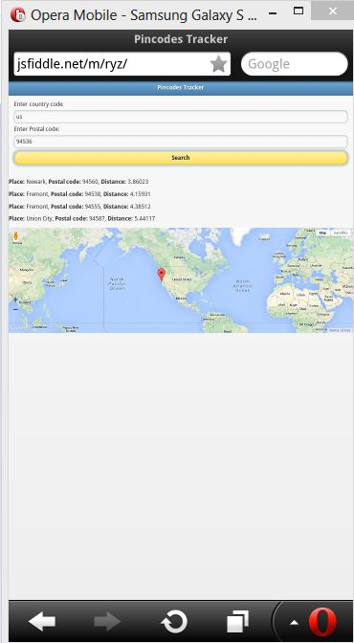

Above screenshot represents the app in the opera mobile emulator.

**Cloud era, Mahout Installation:**

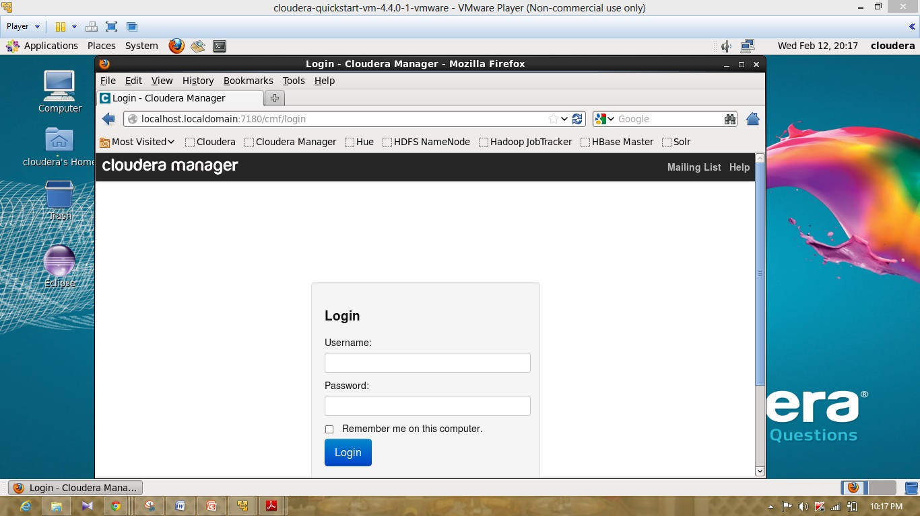

Above screenshot represents the login page of the cloudera manager.

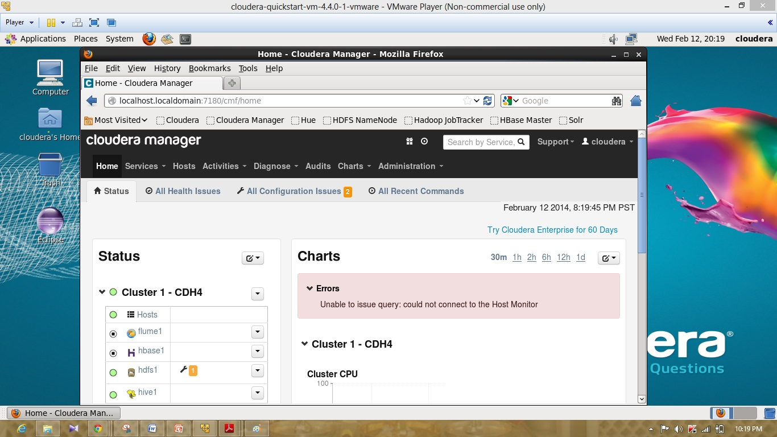

Above screenshot represents the cloudera manager status page.

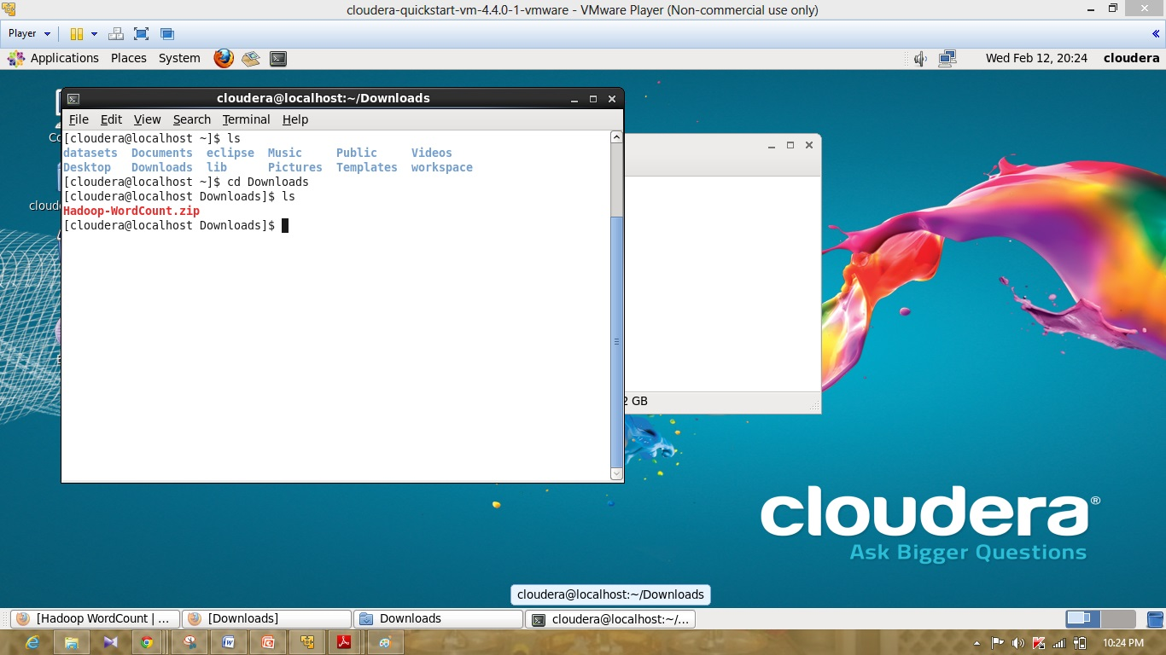

Above screenshot represents the download of the hadoop-Wordcount.zip file.

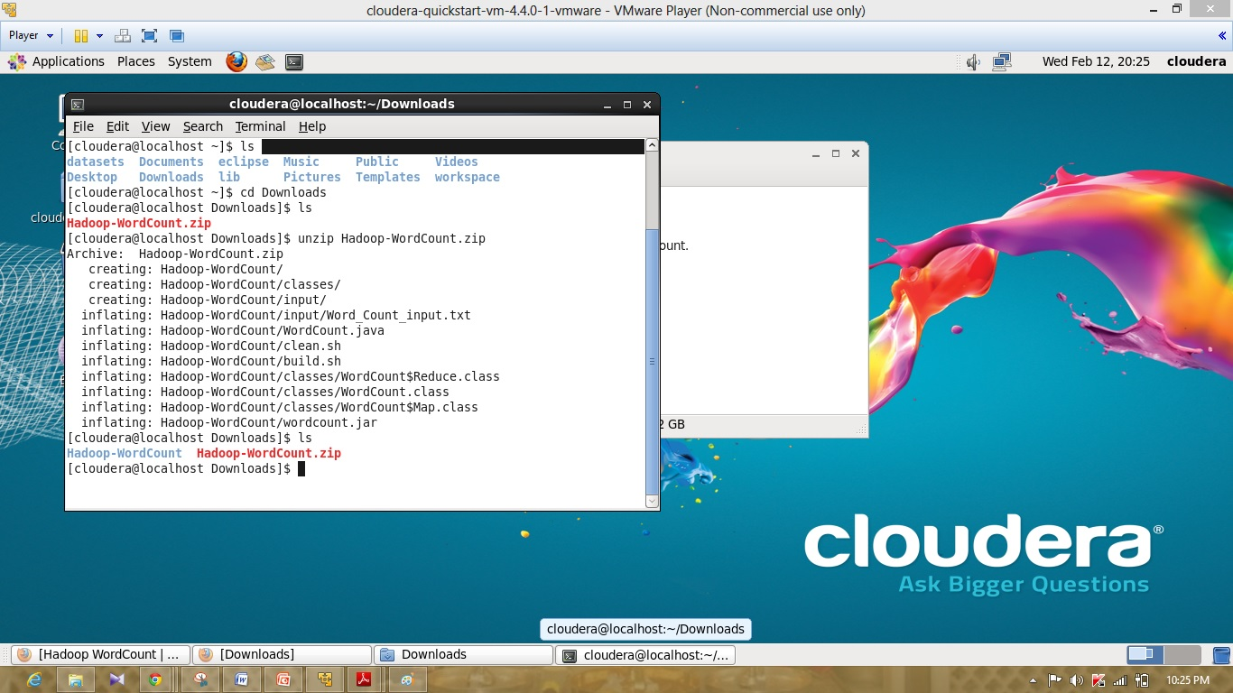

Above screenshot represents the unzip of hadoop-wordcount.zip file.

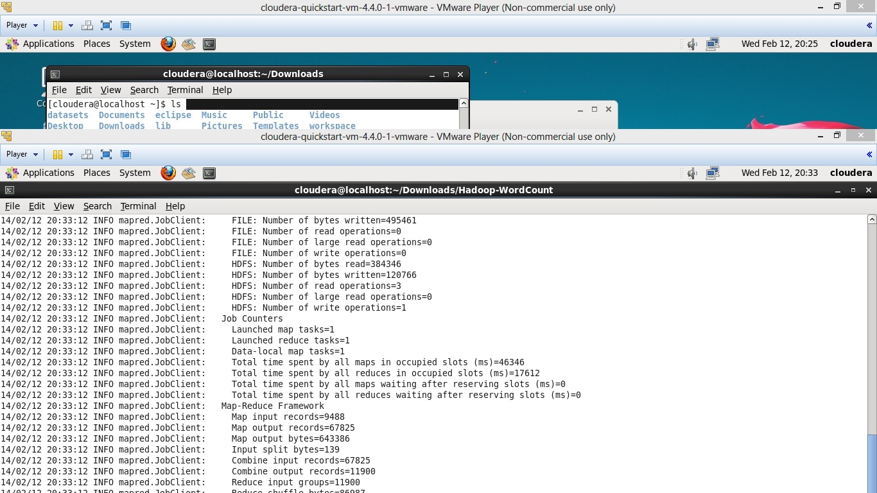

Above screenshot represents the running of hadoop file.

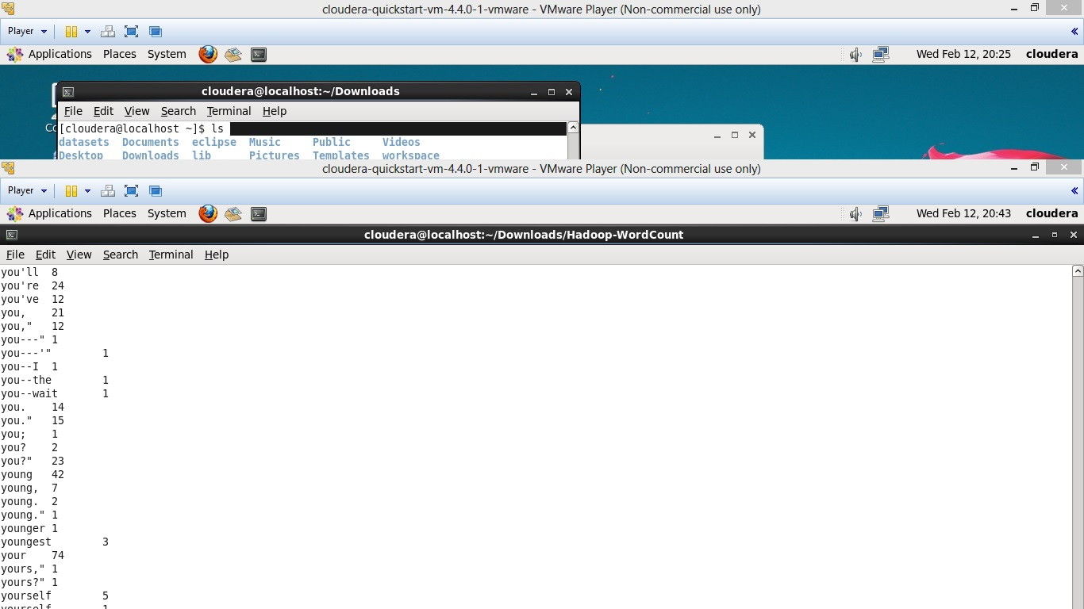

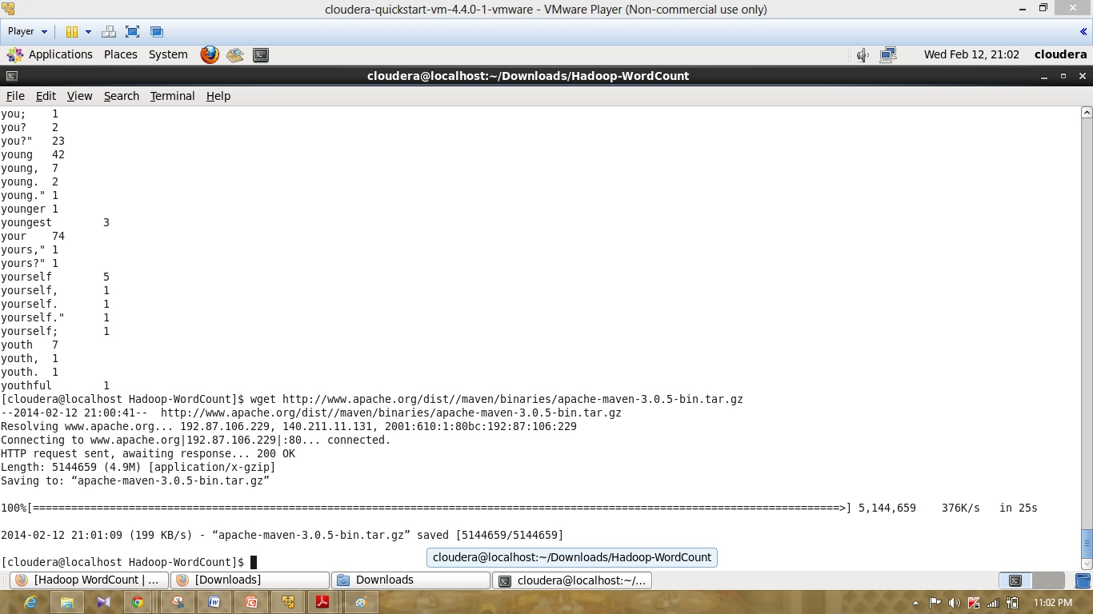

Above screenshots represents the ouput of the wordcount.

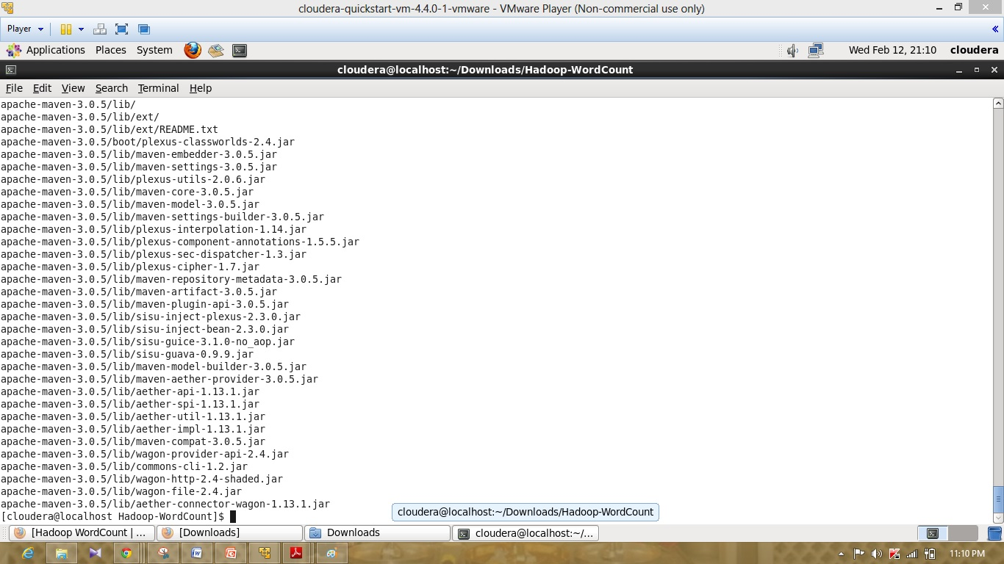

Above screenshot represents the unzip of maven 3.0.5

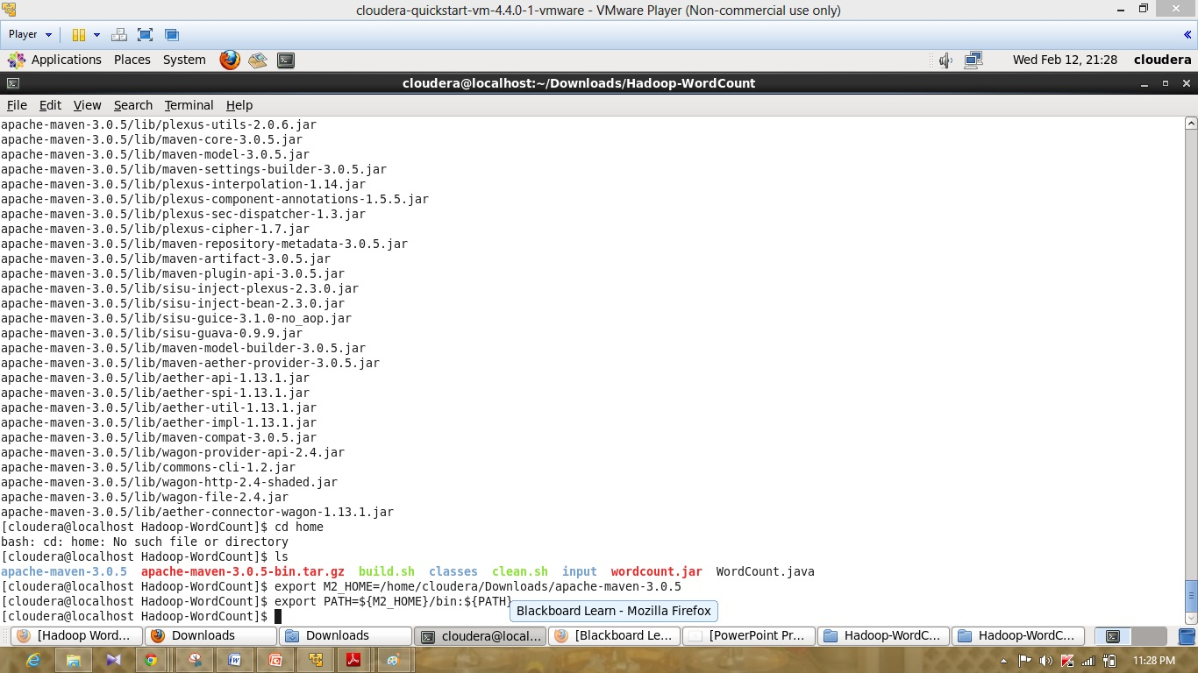

Above screenshot represents the export of the maven file.

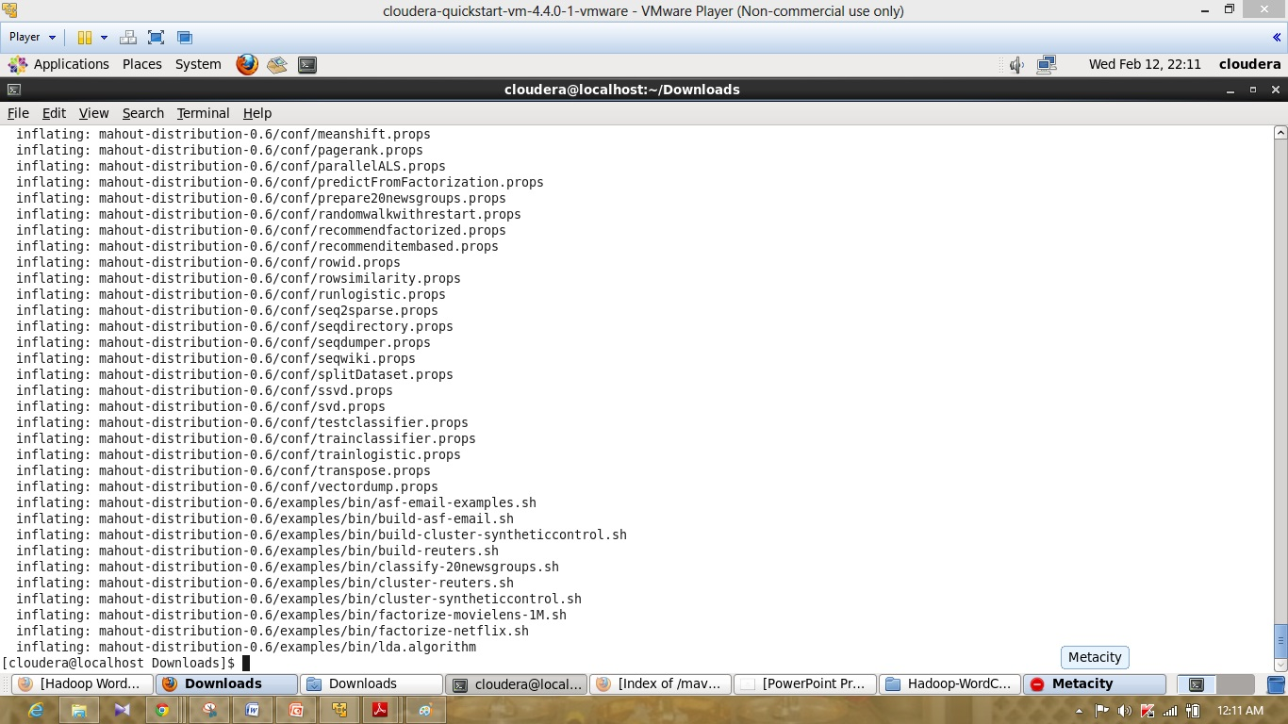

Above screenshot represents the unzip of mahout-distribution-0.6 file.

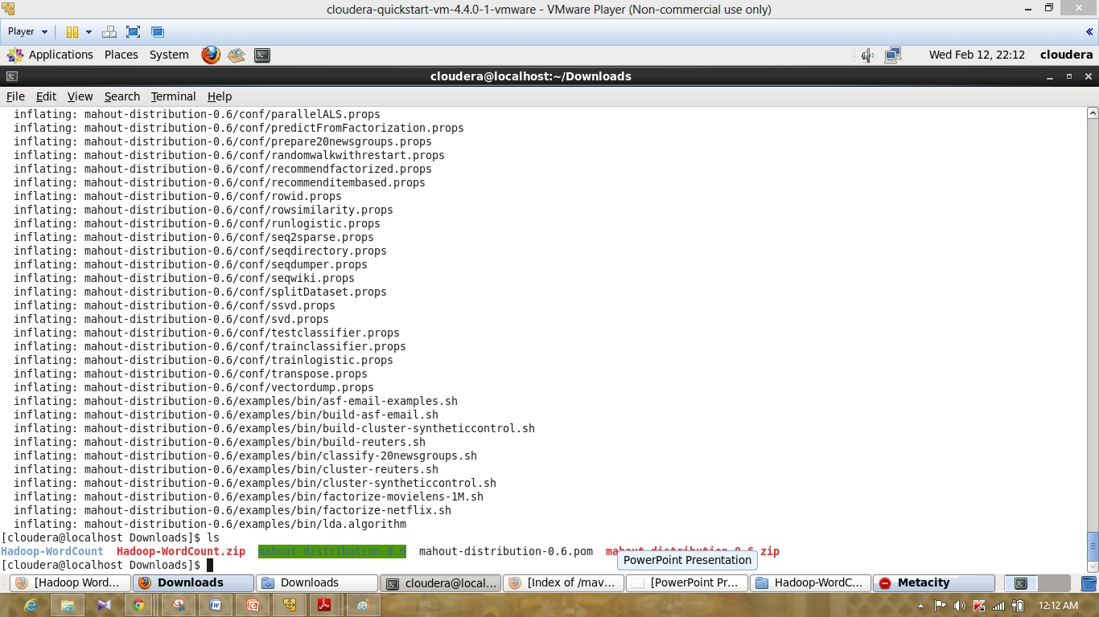

Above screenshot represents the list of file in the downloads

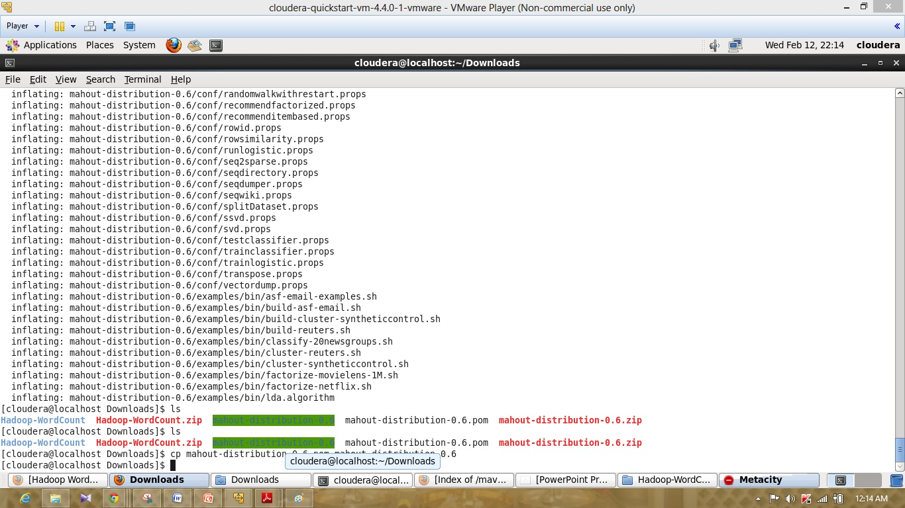

Above screenshot represents the copy of mahout distribution file.

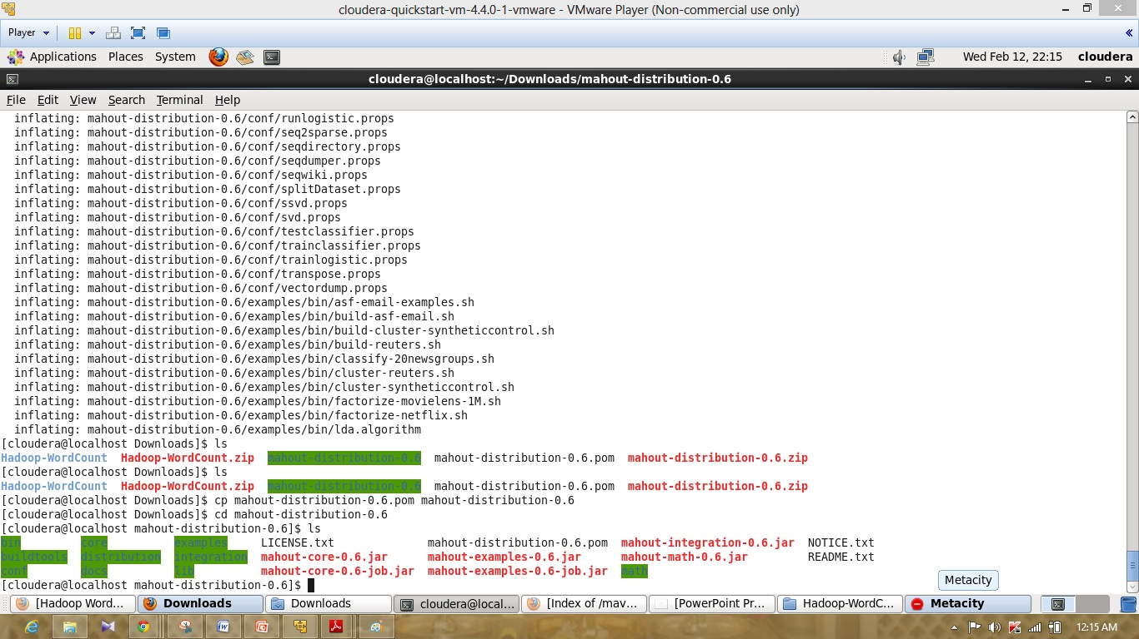

Above screenshot represents the files in mahout-distribution-0.6 directory.

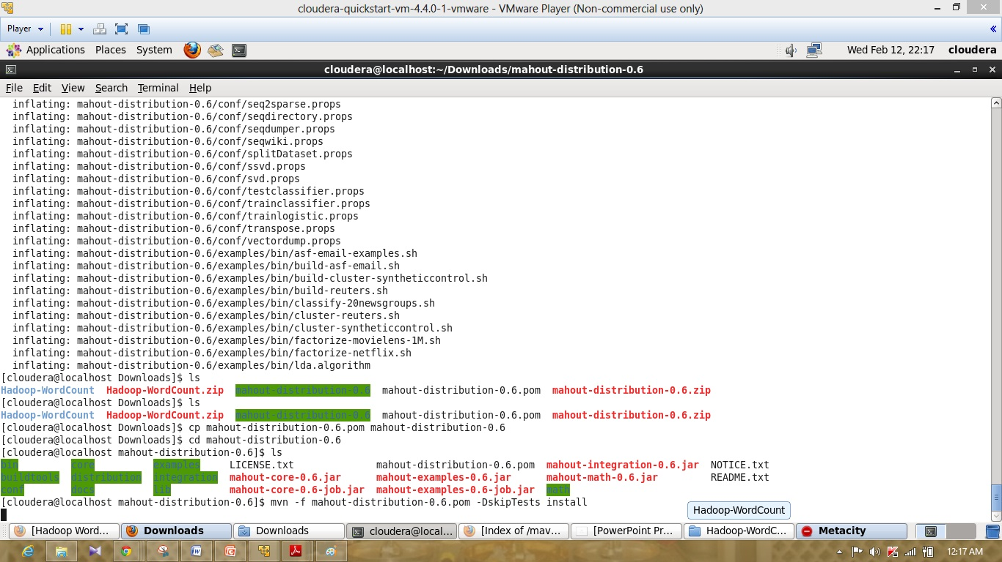

Above screenshot represents the installation of mahout.

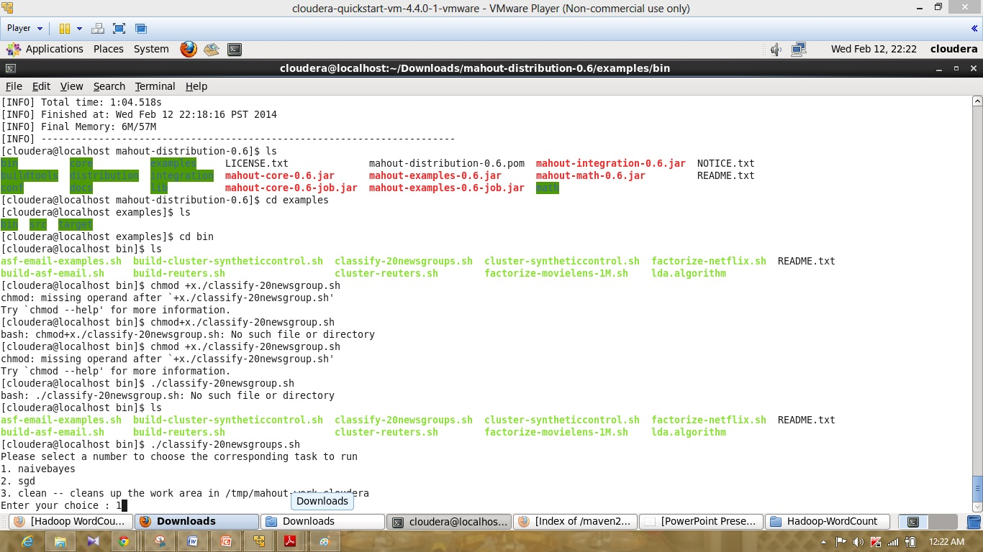

Above screenshot represents the selection of the naivebayes algorithm.

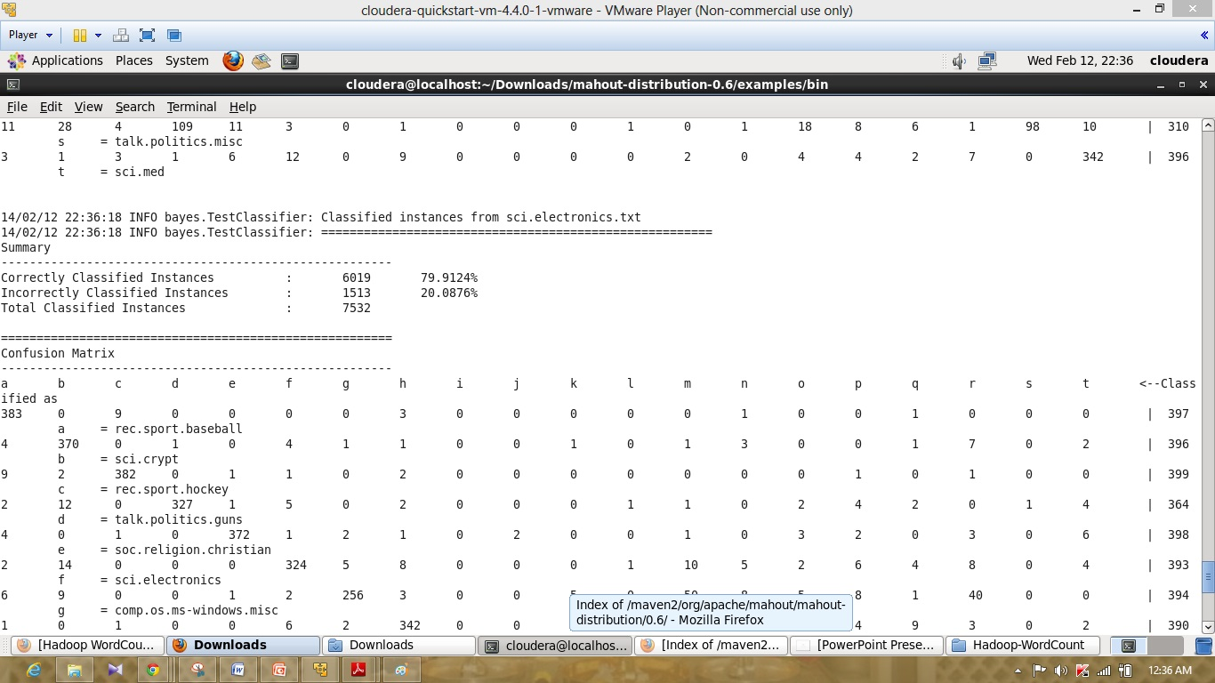

Above screenshot represents the output of the naivebayes algorithm confusion matrix.

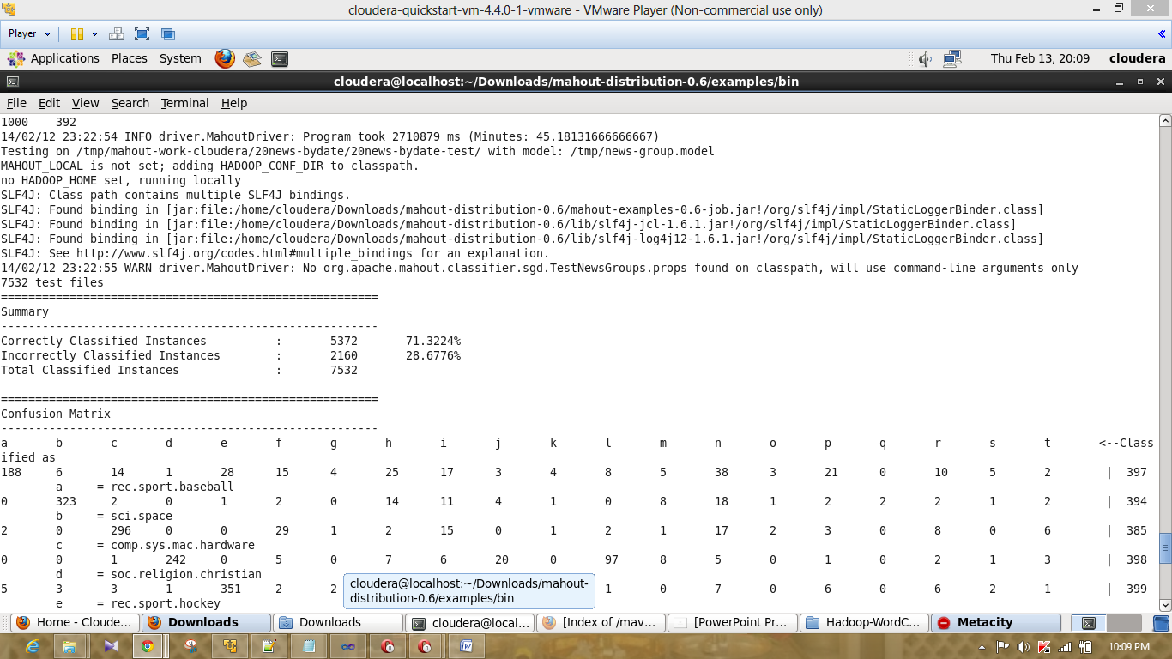

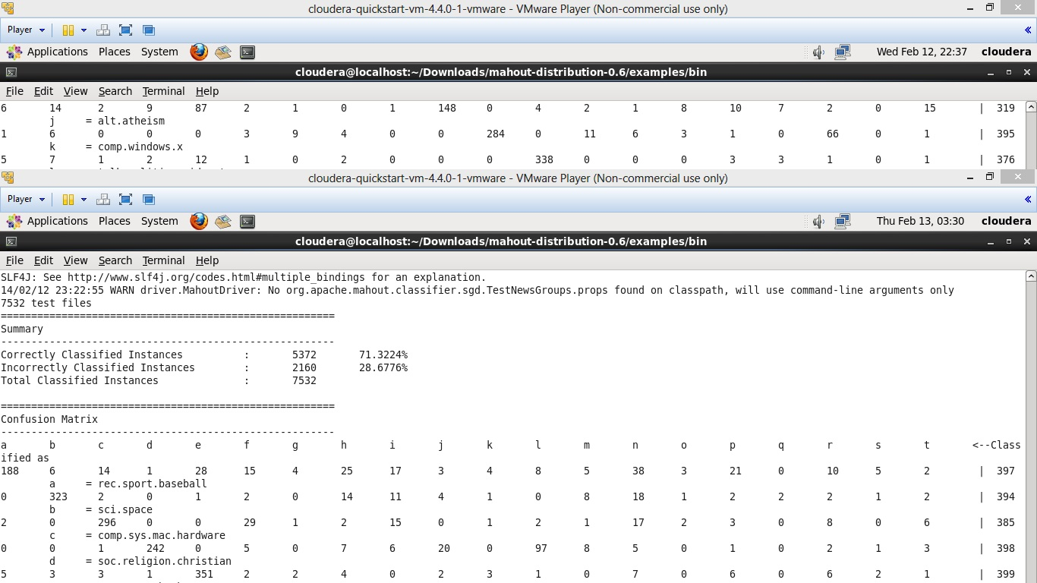

Above screenshot represents the outpur of confusion matrix run by the sgd algorithm.